C E R T I F I C A T E
OF PARTICIPATION

This certificate is proudly presented to:

Allwel Stanley

In recognition of His achievement and participation in the 5 Weeks Intensive M i c r o s o f t PowerBI Bootcamp.
Held from 16th April - 16th May 2026.

Esisi Tosan
Manager, Learning & knowledge management

Dr. Excel Ukpohor
Manager, Digital & Innovations department






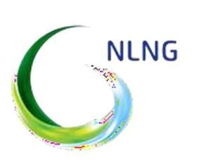
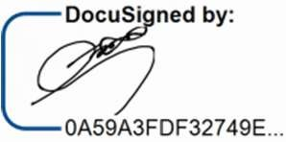
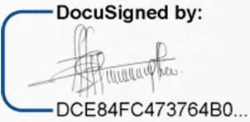

25TH MAY 2026

